

**MCR3U: 1.4 - Determining the Domain and Range of a Function**

**Make a Copy/**

**/30**

| K:  **/8** | T:  **/7** | C:  **/7** | A:  **/8** |
| --- | --- | --- | --- |

Purpose of Assessment: **Assessment of Learning**

Method of Assessment**: KTCA Four Level + /-**

| **Ontario Curriculum Expectations** | |
| --- | --- |
| **A1.1** | explain the meaning of the term function, and distinguish a function from a relation that is not a function, through investigation of linear and quadratic relations using a variety of representations |
| **A1.3** | explain the meanings of the terms domain and range, through investigation using numeric, graphical, and algebraic representations of the functions f(x) = x, f(x) = x2 , f(x) = , and f(x) = ; describe the domain and range of a function appropriately ; and explain any restrictions on the domain and range in contexts arising from real-world applications |

Name: ________________________ Score: /

**Teacher:**  **Date:** **Time:**

***General Instructions: Answer the problem correctly, support your answer with a solution.***

1. State the Domain and Range of each Relation. **[K:1,T:1,C:1,A:1]**

f(x) = { ( Brown, Dog) , ( Blue, Whale), (Green, Frog), (White, Zebra), ( Violet, Horse) }

1. State the Domain and Range of each Relation. **[K:1,T:1,C:1,A:1]**

| **Planet** | **Country** |
| --- | --- |
| Mercury | France |
| Venus | Germany |
| Earth | Singapore |
| Mars | Philippines |
| Jupiter | Taiwan |

1. State the Domain and Range of each Relation. **[K:1,T:1,C:1,A:1]**









* + 4. State the Domain and Range of each Coordinates. **[K:1,T:1,C:1,A:1]**

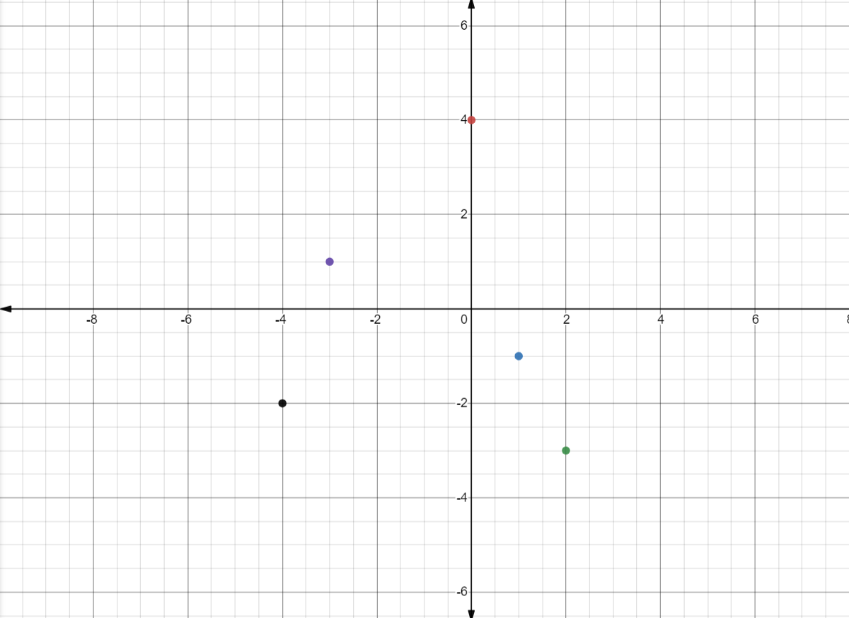

5. State the Domain and Range of each Relation. **[K:1,T:1,C:1,A:1]**

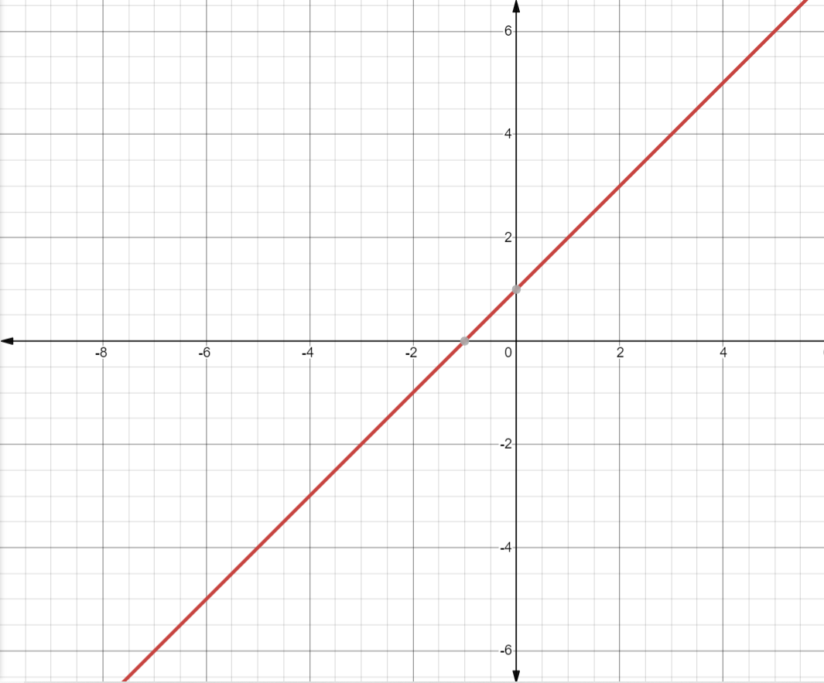

6. State the Domain and Range of the Function. **[K:1,T:1,C:1,A:1]**

**f(x) =**

7. Paul fire a ball up in the air and find the height *h*, in meters, as a function of time *t*, in seconds, is given by h = 20t − 4.9t2 Find the domain and range for the function *h*(*t*). **[K:2 , T:1, C:1, A:2 ]**